The Harklean Syriac of 1 Timothy 3:16

Covering Verses Translating Εὐσέβεια

Graham G. Thomason, March 2019. Revised 15 January 2023
Available on www.FarAboveAll.com

Introduction
This article forms part of a study of the reading of 1 Timothy 3:16. We wish to establish whether the reading is God was manifested in the flesh (the traditional reading) or He was manifested in the flesh, as given in most modern Bibles. Elsewhere we have investigated the Bible manuscript evidence the lectionary evidence and the Church Father evidence. The present study is concerned with the Harklean (also spelled Harkleian) Syriac version, dated AD 616.

The issue simplified, in English only
There is a Greek word meaning godliness or piety which occurs 15 times in the New Testament. In the Harklean Syriac it has the literal translation beauty-of-fear 14 times, and just fear once. One of the 14 cases is 1 Timothy 3:16, where the word piety / beauty-of-fear is followed by God in Greek, and by God in the Harkleian Syriac. Yet there are critics who claim that the word God is to be disallowed in translating the Harklean in 1 Timothy 3:16, because of an apparent rule that if the verse is 1 Tim 3:16 – and this verse only – then the Syriac for piety changes from beauty-of-fear to beauty-of-fear-of-God, with the result that God is eliminated in the English of the Harklean – swallowed up in the word piety. Readers must assess the fairness of this for themselves. We simply present the issue in a factual way, by presenting the Greek and Syriac of the relevant verses.

The issue as expressed by Burgon
This study is a verification of an observation made by Dean John William Burgon, in The Revision Revised on page 489, quoting in the following summary the editor of the Version, the Rev. Henry Deane, of S. John's College, Oxford:
To the VIIth century [A.D. 616] belongs the Harkleian (or Philioxenian) Version; concerning which see above, page 450. “That Θεός was the reading of the manuscripts from which this version was made, is put beyond reach of doubt by the fact that in twelve* of the other places where εὐσέβεια occurs, the words ܫܦܝܪܘܬ ܕܚܠܬܐ (‘beauty-of-fear’) are found without the addition of ܐܠܗܐ (‘God’). It is noteworthy, that on the thirteenth occasion (1 Tim. ii. 2), where the Peschito reads ‘fear of God’, the Harkleian reads ‘fear’ only.** On the other hand, the Harkleian margin of Acts iii. 12 expressly states that εὐσέβεια is the Greek equivalent of ܫܦܝܪܘܬ ܕܚܠܬܐ (‘beauty-of-fear’). This effectually establishes the fact that the author of the Harkleian recension found Θεός in his Greek manuscript of 1 Tim. iii. 16”
* Burgon, or rather Rev. Henry Deane, omits 1 Timothy 6:11, but we include it, so covering all occurrences of εὐσέβεια.
** It is the Harkleian that corresponds to the Greek (which does not contain the word for ‘God’ in 1 Tim. ii. 2). The Peschito adds the word for ‘God’. But we are not particularly concerned with the Peschito here.
Typographic note.
The Syriac alef is rendered in a standard font, which is an Estrangela font, by ܐ in this document, but in the scans we reproduce, it is in a Serta font. For readers not familiar with Syriac, but attempting to at least match Syriac words in our description with those in the Harklean publication, the table below shows equivalent words.
 |  | Our font (Estrangela) | Harklean book printed font (Serta) | Transcription
Beauty of | } piety | ܫܦܝܪܘܬ |  | shafirut
Fear [of] |  | (ܐ)ܕܚܠܬ | 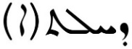 | dechilat(a)
God |  | ܐܠܗܐ |  | Aloha
The letter in the round brackets in the Syriac makes the word determinate (the fear / fear), otherwise it is in a construct form (fear-of). So the inclusion word in square brackets in the English corresponds to the absence of the bracketed letter in the Syriac.

Translation note
Readers should note that the English word “godliness” (used in the AV and FarAboveAll translations) is not a translation of a word, or phrase, containing the word “God” in Greek or Syriac. To avoid confusion, we translate the Greek and Syriac equivalents by “piety” in this study. Similarly, we replace “godly” by “pious”.

The Harklean Syriac Text
A scan of a printed edition of the Harklean Syriac is available online (see our References). The two volumes were digitized by Google, and are for personal, non-profit use, so we request that Google's Usage Guidelines are respected. The title pages shown below.
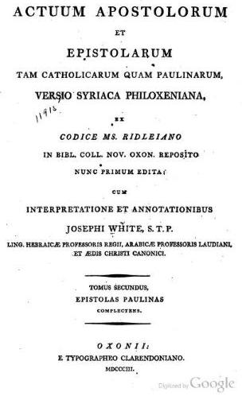
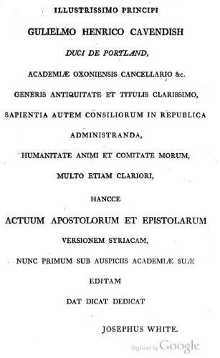

The Verse-by-Verse Study of the Translations of Εὐσέβεια in the Harklean Syriac
We consider all verses where the Greek contains the word εὐσέβεια .We will consider 1 Tim 3:16 last. In each case, we first give the Greek from the Majority Text (Robinson-Pierpont Byzantine Textform 2005) and an English translation of the Greek, from the FarAboveAll translation (but using the word “piety” rather than “godliness”, and “pious” rather than “godly” as explained above).

Acts 3:12
Ἰδὼν δὲ Πέτρος ἀπεκρίνατο πρὸς τὸν λαόν, Ἄνδρες Ἰσραηλῖται, τί θαυμάζετε ἐπὶ τούτῳ, ἢ ἡμῖν τί ἀτενίζετε, ὡς ἰδίᾳ δυνάμει ἢ εὐσεβείᾳ πεποιηκόσιν τοῦ περιπατεῖν αὐτόν;
And when Peter saw this, he answered the people, “You Israelite men, why are you astonished at this, or why do you look at us so intently as if it were by our own power or piety that we made him walk?
Harklean Syriac (archive.org Vol I, electronic page n43, printed page number 15):
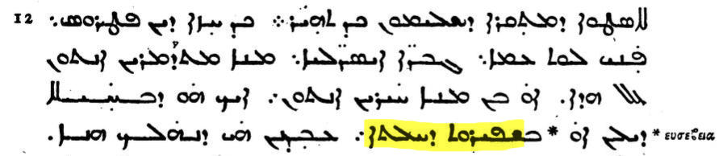
The translation of εὐσέβεια is ܫܦܝܪܘܬ ܕܚܠܬܐ. The marginal note expressly confirms this, as Burgon observed.

1 Timothy 2:2
ὑπὲρ βασιλέων καὶ πάντων τῶν ἐν ὑπεροχῇ ὄντων, ἵνα ἤρεμον καὶ ἡσύχιον βίον διάγωμεν ἐν πάσῃ εὐσεβείᾳ καὶ σεμνότητι.
for kings and all those in high positions, so that we may lead a quiet and calm life in all piety and solemnity,
Harklean Syriac (archive.org Vol II, electronic page n283, printed page number 274):
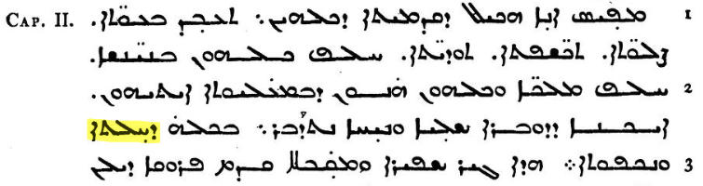
The translation of εὐσέβεια is ܕܚܠܬܐ (so withoutܫܦܝܪܘܬ in this case).

1 Timothy 4:7 and 4:8
⁷Τοὺς δὲ βεβήλους καὶ γραώδεις μύθους παραιτοῦ. Γύμναζε δὲ σεαυτὸν πρὸς εὐσέβειαν·
⁸ἡ γὰρ σωματικὴ γυμνασία πρὸς ὀλίγον ἐστὶν ὠφέλιμος· ἡ δὲ εὐσέβεια πρὸς πάντα ὠφέλιμός ἐστιν, ἐπαγγελίαν ἔχουσα ζωῆς τῆς νῦν καὶ τῆς μελλούσης.
⁷But reject profane and old wives' tales and exercise yourself rather to piety.
⁸For physical exercise is beneficial in a minor matter, but piety is beneficial in all respects, having the promise of present and future life.
Harklean Syriac (archive.org Vol II, electronic page n287, printed page number 279):
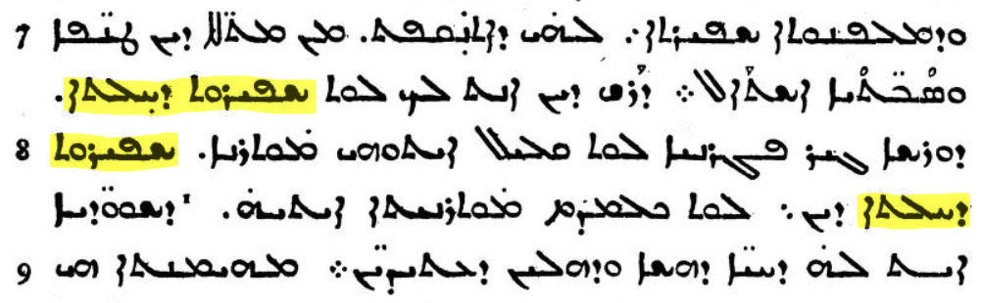
In both cases, the translation of εὐσέβεια is ܫܦܝܪܘܬ ܕܚܠܬܐ.

1 Timothy 6:3, 6:5, 6:6, 6:11
³Εἴ τις ἑτεροδιδασκαλεῖ, καὶ μὴ προσέρχεται ὑγιαίνουσιν λόγοις, τοῖς τοῦ κυρίου ἡμῶν Ἰησοῦ χριστοῦ, καὶ τῇ κατ' εὐσέβειαν διδασκαλίᾳ, ⁴... ⁵διαπαρατριβαὶ διεφθαρμένων ἀνθρώπων τὸν νοῦν, καὶ ἀπεστερημένων τῆς ἀληθείας, νομιζόντων πορισμὸν εἶναι τὴν εὐσέβειαν. Ἀφίστασο ἀπὸ τῶν τοιούτων. ⁶Ἔστιν δὲ πορισμὸς μέγας ἡ εὐσέβεια μετὰ αὐταρκείας· ⁷... ⁸... ⁹... ¹⁰... ¹¹Σὺ δέ, ὦ ἄνθρωπε τοῦ θεοῦ, ταῦτα φεῦγε· δίωκε δὲ δικαιοσύνην, εὐσέβειαν, πίστιν, ἀγάπην, ὑπομονήν, πρᾳότητα.
³If anyone teaches another doctrine and does not adhere to sound words – those of our Lord Jesus Christ and to the pious doctrine – ⁴... ⁵vain arguments of men corrupt in mind and devoid of the truth, who reckon piety to be a means of gain. Do not associate with such. ⁶But piety with independence is an important means of gain. ⁷... ⁸... ⁹... ¹⁰... ¹¹But you, O man of God, flee from these things, and pursue righteousness, piety, faith, love, patience, meekness.
Harklean Syriac (archive.org Vol II, electronic pages n293-295, printed page numbers 284-286)
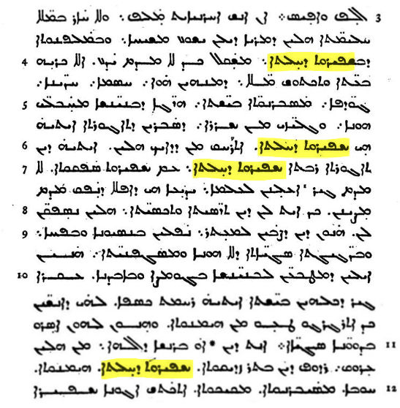
In all these cases, the translation of εὐσέβεια is ܫܦܝܪܘܬ ܕܚܠܬܐ.

2 Timothy 3:5
ἔχοντες μόρφωσιν εὐσεβείας, τὴν δὲ δύναμιν αὐτῆς ἠρνημένοι· καὶ τούτους ἀποτρέπου.
having a form of piety, but having denied the power of it. From these also turn away.
Harklean Syriac (archive.org Vol II, electronic page n305, printed page number 296)
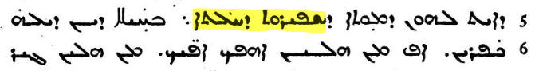
The translation of εὐσέβεια is ܫܦܝܪܘܬ ܕܚܠܬܐ.

Titus 1:1
Παῦλος, δοῦλος θεοῦ, ἀπόστολος δὲ Ἰησοῦ χριστοῦ, κατὰ πίστιν ἐκλεκτῶν θεοῦ καὶ ἐπίγνωσιν ἀληθείας τῆς κατ' εὐσέβειαν,
From Paul, a servant of God, and an apostle of Jesus Christ, according to the faith of God's elect and acknowledgment of the truth which is in accordance with piety,
Harklean Syriac (archive.org Vol II, electronic page n311, printed page number 303)

The translation of εὐσέβεια is ܫܦܝܪܘܬ ܕܚܠܬܐ.

2 Peter 1:3
ὡς πάντα ἡμῖν τῆς θείας δυνάμεως αὐτοῦ τὰ πρὸς ζωὴν καὶ εὐσέβειαν δεδωρημένης, διὰ τῆς ἐπιγνώσεως τοῦ καλέσαντος ἡμᾶς διὰ δόξης καὶ ἀρετῆς·
since his divine power has bestowed on us everything pertaining to life and piety through acknowledgment of him who called us through glory and virtue,
Harklean Syriac (archive.org Vol I, electronic page n259, printed page number 231)
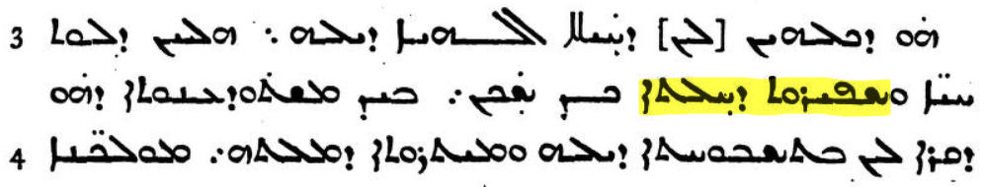
The translation of εὐσέβεια is ܫܦܝܪܘܬ ܕܚܠܬܐ.

2 Peter 1:6 and 1:7
ἐν δὲ τῇ γνώσει τὴν ἐγκράτειαν, ἐν δὲ τῇ ἐγκρατείᾳ τὴν ὑπομονήν, ἐν δὲ τῇ ὑπομονῇ τὴν εὐσέβειαν, ⁷ἐν δὲ τῇ εὐσεβείᾳ τὴν φιλαδελφίαν, ἐν δὲ τῇ φιλαδελφίᾳ τὴν ἀγάπην.
and in your knowledge, self-control, and in your self-control, endurance, and in your endurance, piety, ⁷and in your piety, brotherly affection, and in your brotherly affection, love.
Harklean Syriac (archive.org Vol I, electronic page n261, printed page number 232)
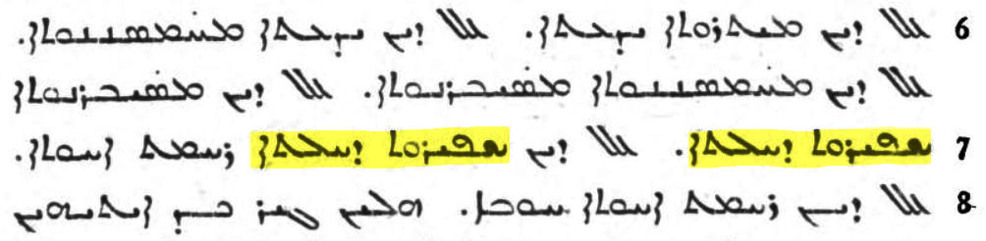
In both cases, the translation of εὐσέβεια is ܫܦܝܪܘܬ ܕܚܠܬܐ.

2 Peter 3:11
Τούτων οὖν πάντων λυομένων, ποταποὺς δεῖ ὑπάρχειν ὑμᾶς ἐν ἁγίαις ἀναστροφαῖς καὶ εὐσεβείαις,
Seeing that all these things are to be dissolved, then, what kind of people should you be in holy conduct and piety,
Harklean Syriac (archive.org Vol I, electronic page 269, printed page numbers 240-241)
The translation of εὐσέβεια is ܫܦܝܪܘܬ ܕܚܠܬܐ.
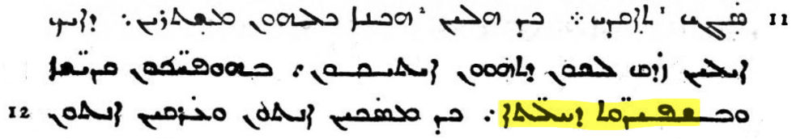

**** We now come to the crux of the matter. Does 1 Timothy 3:16 read God or not? ****

1 Timothy 3:16
Majority Text (Robinson-Pierpont Byzantine Textform 2005, FarAboveAll English)
Καὶ ὁμολογουμένως μέγα ἐστὶν τὸ τῆς εὐσεβείας μυστήριον· θεὸς ἐφανερώθη ἐν σαρκί, ἐδικαιώθη ἐν πνεύματι, ὤφθη ἀγγέλοις, ἐκηρύχθη ἐν ἔθνεσιν, ἐπιστεύθη ἐν κόσμῳ, ἀνελήφθη ἐν δόξῃ.
[A pillar and base of the truth,] and confessedly great, is the mystery of godliness: God was manifested in the flesh, justified in the spirit, seen by angels, preached among the Gentiles, believed on in the world and taken up in glory.
Harklean Syriac (archive.org Vol. II, electronic page n287, printed page number 278):
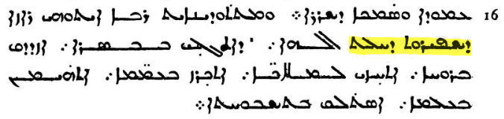
We have shown that in all other verses the translation of εὐσέβεια is ܫܦܝܪܘܬ ܕܚܠܬ. And so is it here. The word following ܫܦܝܪܘܬ ܕܚܠܬ, namely ܐܠܗܐ, is never used anywhere else to part-translate εὐσέβεια, which means that neither is it here. The word ܐܠܗܐ is a stand-alone word, God, in 1 Tim 3:16. There is no justification for swallowing it up in the translation of εὐσέβεια.

The Harklean version therefore reads
the mystery of godliness towards God, who was manifested in the flesh
which must have come from a Greek reading of
τὸ τῆς εὐσεβείας μυστήριον· θεὸς ἐφανερώθη ἐν σαρκί
or perhaps (though no Greek manuscript contains it)
τὸ τῆς εὐσεβείας μυστήριον· θεὸς ὃς ἐφανερώθη ἐν σαρκί
and certainly not
τὸ τῆς εὐσεβείας μυστήριον· ὃς ἐφανερώθη ἐν σαρκί

We have shown that Burgon's astute observation is correct, and that Bishop Ellicott (the chairman of the Revising Committee) has put the Harklean version on the wrong side of the dispute.

The Revising Committee for the Revised Version adopted the ὃς ἐφανερώθη ἐν σαρκί (he was manifested in the flesh) reading partly through Ellicott's– or rather his informants' – misinformation. The error has persisted to modern times. The Textual Commentary on the Greek New Testament, 1971 edition, by Bruce Metzger, which attempts to justify the Nestle-Aland / United Bible Societies reading ὃς, and which will have been consulted by many a translator, states that “all ancient versions presuppose ὃς or ὁ”. The Harklean is one example showing the falsity of the statement; for the other ancient versions supporting θεός (Georgian and Slavonic), see Burgon's The Revision Revised. Burgon shows that the bulk of the other ancient versions (Latin, Peshitta, Coptic, Ethiopic and Armenian) support ὁ not ὃς, and so do not support the Nestle-Aland / United Bible Societies reading. Only the Gothic supports ὃς.

References

The Harklean Syriac is available online. We found a link on this page
http://syri.ac/bibliography/379437680

which links to this volume for Paul's epistles:
https://archive.org/details/ActuumApostolorumEtEpistolarumTamCa2/page/n287

For Acts and the Catholic Epistles, the link is:
https://archive.org/details/ActuumApostolorumEtEpistolarumTamCa/page/n31

The Revision Revised J. W. Burgon, The Revision Revised, originally published 1883.

https://archive.org/details/revisionrevised00burggoog

[UBS-Commentary] Bruce Metzger, in cooperation with The United Bible Societies,

A Textual Commentary on the Greek New Testament

published by and obtainable from

Deutsche Bibelgesellschaft, P.O. Box 810340, 7000 Stuttgart 80, Germany.

ISBN 3 438 06010 8.

For the Bible and lectionary manuscripts, see www.faraboveall.com/015_Textual/01_Textual.html; Church Father investigations are in progress at the time of writing, but see www.berenddeboer.net/article/1_timothy_3_16.html
Burgon spells it Harkleian, and we retain that spelling quoting him and in our remarks following. Elsewhere, we use the more usual spelling Harklean. The translator is spelled Thomas of Harqel in Wikipedia. We also retain Burgon's spelling Peschito (another Syriac translation) when quoting him, but the more common Peshitta elsewhere.
I.e. not one out of 584 we have examined, these being almost all known, and all that are available in online scans. See our summary on www.faraboveall.com/015_Textual/01_Textual.html.
For Bishop Ellicott's position, see The Revision Revised, p. 429 (where the Harklean is called the Philoxenian).

