Aramaic / Syriac Primacy?

Graham G. Thomason, 20th February 2019
Revised 28 February 2021, 11 January 2023, 20 January 2023
This article is on www.FarAboveAll.com

We present some points concerning Aramaic Primacy – the claim that Aramaic is the original language of the New Testament.

- Syriac is a form of Aramaic, and the most widely known edition of the bible in Syriac is the Peshitta (ܦܫܝܛܬܐ). The word means “Simple”, and is contrasted with the Qadma (ܩܕܡܐ), the “Old”. The Simple and the Old what? The Simple and the Old Translation, we claim.

- The salutation to Hebrews 1:1 indicates that the epistle was written by Paul the apostle. Paul's typical salutation is ΠΑΥΛΟΣ, ΑΠΟΣΤΟΛΟΣ (Paul, an apostle). The epistle to the Hebrews starts with ΠΟΛΥΜΕΡΩΣ ΚΑΙ ΠΟΛΥΤΡΟΠΩΣ (In many stages and in many ways). This may not look like a salutation, but ΠΟΛΥΜΕΡΩΣ ΚΑΙ contains the letters of ΠΑΥΛΟΣ and ΚΑΙ ΠΟΛΥΜΕΡΩΣ contains the letters of ΑΠΟΣΤΟΛΟΣ, though the letters ΑΟΣ require sharing.
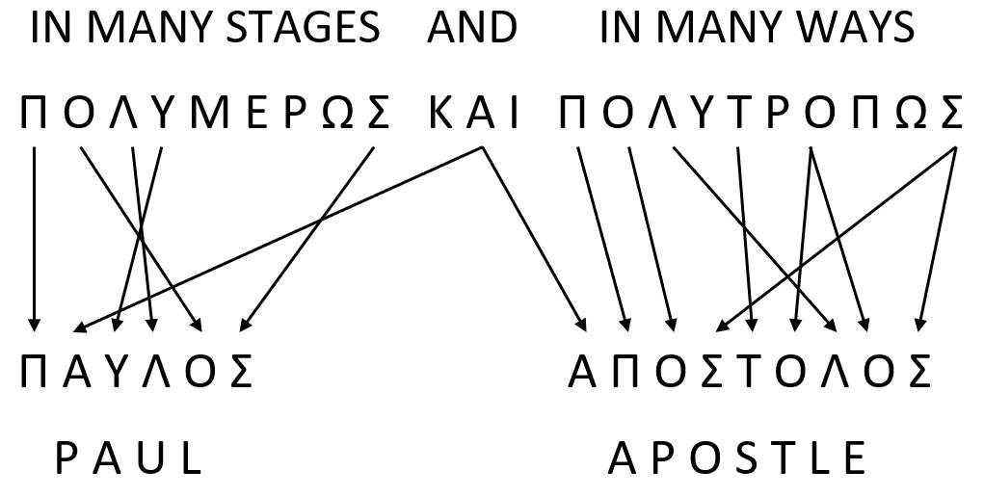

This decoding does not work in the Syriac Peshitta. One does not obtain ܦ݁ܰܘܠܳܘܣ ܫܠܺܝܚܳܐ (Paulaus shelicha - Paul an apostle) from ܒ݁ܟ݂ܽܠ ܡܢܰܘܳܢ ܘܰܒ݂ܟ݂ܽܠ ܕ݁ܶܡܘܳܢ (bekul menawan wabkul demwan - in many parts and in many forms). We regard this as evidence that the New Testament was originally written in Greek, not Aramaic.

- In 1 Tim 3:16, with the Peshitta as primary, we would lose the precious Greek Majority Text reading
μυστήριον· θεὸς ἐφανερώθη ἐν σαρκί
mystery; God was manifested in the flesh,
instead reading [BFBS Peshitta]
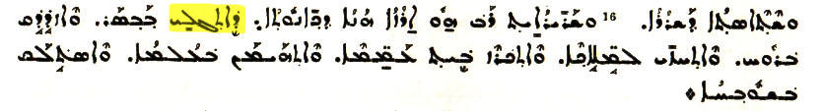

mystery which was manifested in the flesh
- a reading only supported by one Greek manuscript (D).

- We are not aware of any discoveries of gematria of the Syriac bible, but there may be some. For gematria of the Greek New Testament, see Bullinger's Number in Scripture. As examples of Greek gematria, we mention Ἰησοῦς= 888, and we take a phrase from Rev 12:9
ὁ καλούμενος διάβολος καὶ {RP: - } [P1904 TR: ὁ] Σατανᾶς
who is called devil and [the] Satan
which in gematria is 2197 = 13³, a number deeply associated with Satan, provided we take the P1904 TR (Patriarchal Greek Church and Received Text) reading, not the RP (Robinson-Pierpont) one. The P1904 TR reading is supported by about 44% of manuscripts, (110 for, 142 against, 12 with a hiatus, judging by Hoskier's data, from Concerning the Text of the Apocalypse, Vol. 2):
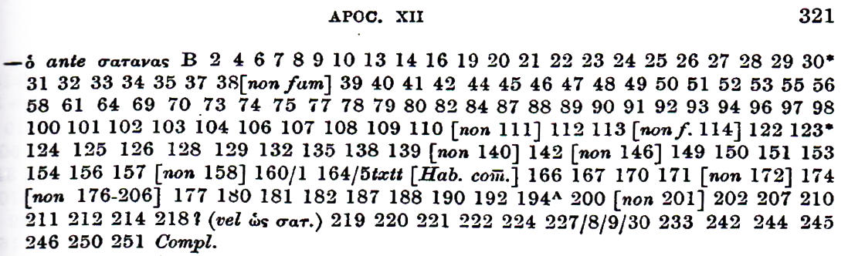

- The original Peshitta did not contain 2 Peter, 2 John, 3 John, Jude, Revelation. We regard these as essential to the New Testament, recognizing references to nephilim in some places in some of these books (an unpopular topic to many).

- The Peshitta contains some Greek words. If Syriac was the original language, why is even the name of book of Acts called ܦܪܟܣܣ, as if from the Greek New Testament (Πράξεις), rather than being given a Syriac name?

- The Greek New Testament contains some Syriac words, but also about 30 Latin words. We do not have a list of Latin words in the Peshitta, and there could be some where the Greek equivalent of the Syriac is not borrowed from Latin. The larger presence of Latin words could be a sign of primacy, as contemporary Latin could become less well-known with the passage of time, but we do not press the point. In the Greek text, apart from coins (ἀσσάριον, δηνάριον, κοδράντες), weights and measures (λίτρα, μίλιον, μόδιος), and names of winds (Εὐροκλύδων which may originate from Latin Euraquila, and Χῶρος, perhaps from Latin Corus), which are understandably transliterated, we find the following, with the Peshitta set alongside:
Verse | Latin in  Greek NT | Latin in  Latin script | Peshitta  (L)=Latin  (S)=Syriac | Latin to English | Syriac to English
Acts 21:38 | σικάριος | sicarius | (S) ܥܒܕ ܒܝܫܬܐ | assassin | worker of evil
John 2:15 | φραγέλλιον | flagellum | (L) ܦܪܓܠܐ | whip | whip
2 Cor 2:14 | θριαμβεύω | triumfo | (S) ܥܒܕ + ܚܙܐ | triumph | spectacle + make
Mark 15:39 | κεντυρίων | centurio | (L) ܩܢܛܪܘܢܐ | centurion | centurion
Matt 27:65 | κουστωδία | custodia | (L) ܩܣܛܘܢܪܐ | guard | guard
Matt 26:53 | λεγεών | legio | (L) ܠܓܝܘܢܐ | legion | legion
Matt 27:27 | πραιτώριον | praetorium | (L) ܦܪܛܘܪܝܢ | praetorium | praetorium
Mark 6:27 | σπεκουλάτωρ | speculator | ܐܣܦܘܩܠܛܪܐ  (L) | scout, spy, executioner | spy, scout,  executioner
Matt 22:17 | κῆνσος | census | (S) ܟܣܦ | (poll) tax | money, silver
Acts 16:12 | κολωνεία | colonia | (L) ܩܘܠܘܢܝܐ | colony | colony
Acts 6:9 | Λιβερτῖνος | libertinus | (L) ܠܒܪܛܢ | freedman, libertine | freedman
John 13:4 | λέντιον | linteum | (S) ܣܕܘܢܐ | linen cloth | fine linen
Acts 19:12 | σιμικίνθιον | semicintium | (S) ܪܩܥ | piece of cloth | cloth, patch
Acts 19:12 | σουδάριον | sudarium | (L) ܣܘܕܪܐ | sweat band | sweat band
2 Tim 4:13 | φελόνης | paenula | (S) ܟܬܒܐ ܒܝܬ | cloak | book holder
1 Cor 10:25 | μάκελλον | macellum | (L) ܡܩܠܘܢ | food market | food market
Acts 28:15 | ταβέρνη | taberna | (S) ܚܢܘܬܐ | inn, tavern | shop, tavern
Acts 28:15 | φόρον | forum | (L) ܦܘܪܘܣ | market | market
2 Tim 4:13 | μεμβράνα | membrana | ܕܡܓܠܐ + ܟܪܟܐ (S) | parchment | volume + parchment
John 19:19 | τίτλος | titulus | (S) ܠܘܚ | inscription | tablet

For Wikipedia's discussion, see https://en.wikipedia.org/wiki/Aramaic_New_Testament.
––––––––––––––––––––

See Scrivener's Plain Introduction, Vol. 2, p.8.
The words are taken from A Study of Latin Words in the Greek New Testament by Esther Laverne Benjamin. We exclude from her list ξέστης, pot or cup, χάρτης, paper (an earlier word than charta?), ἔχω, hold (though some derive it from aestimo in certain places, including Luke 14:18).
Syriac mostly taken from http://www.dukhrana.com/peshitta/
The Syriac word has a Greek origin, σινδών.

