The Reading of 1 Timothy 3:16 in Codex C

Copyright © Graham G. Thomason, 2008.
Revised slightly: 3 April 2018, 14 January 2023.
Permission is granted to copy or publish this item for non-commercial use, provided this complete notice is included.
The item can be found at www.FarAboveAll.com.

Does Codex C (technically known as Codex Ephraemi Syri Rescriptus) read God was manifested in the flesh, or as the modern critics claim with absolute certainty, He was manifested in the flesh? We are in the fortunate position of having a scan of the manuscript, so we can see with our own eyes what is going on. When reading the Greek manuscripts, we must be aware that certain “sacred” words are always contracted, and written with a line on top, so that God, Q6EO56, (theos) is written Q656.

Here is a scan of the manuscript, from the facsimile in F.H.A. Scrivener's A Plain Introduction to the Criticism of the New Testament. It is unfortunately a palimpsest, i.e. it has lower (original) writing, and has been scrubbed and re-used for upper writing. But the lower writing is still clearly visible.
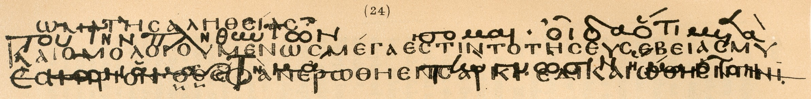

The box marks the contested area, with Q656 or O656 at the bottom left, giving God or He was manifested in the flesh. We enlarge the box area and study it later.

In order to help the reader orientate himself, the following shows the lower scripture text, produced by replacing the upper writing by the background colour. Where the lower text has been overwritten by the upper text, we make a fair guess as to how much black to remove so as to reveal how the lower text stood. Nowhere has any black been added.

It reads:
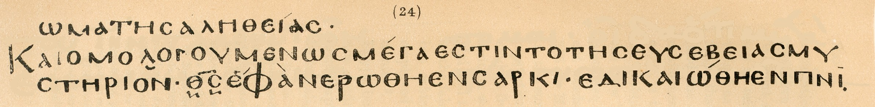
wma th=j a)lhqei/aj
kai\ o9mologoume/nwj me/ga e0sti\n to\ th=j eu0sebei/aj mu
sth/rion: Q656 e0fanerw&qh e0n sarki/, e0dikaiw&qh e0n pni6 ¨=pneu/mati©.

A literal translation is:
(founda)tion of-the truth
and confessedly great is the of-the godliness my
stery: God was-manifested in flesh, justified in spirit.

The following is the upper text.
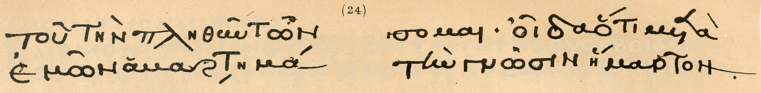

It is, we are informed by Scrivener, a Greek translation of St. Ephraim the Syrian. It reads:
tou= th\n plhqu=n tw~n somai: oi]da o3ti meta_
e0mw~n a(marthma& th\n gnw~sin h3marton

Let us examine the contested area in more detail.
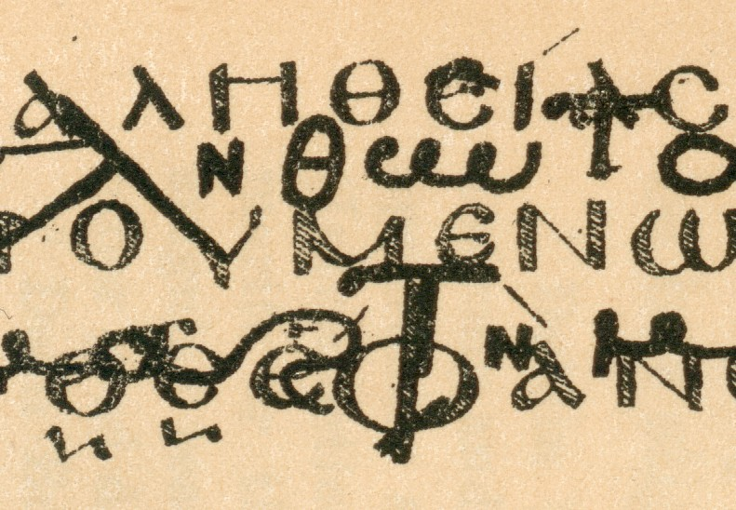
1
Q5
2
epsilon

Tischendorf (the champion of modern textual criticism) claimed that the horizontal line in the theta of Q5 is an addition by a later scribe. His first argument is that the line slopes upwards. But observe the epsilon of a)lhqei/aj , marked (2). It also slopes upwards - and is in the scribe's thin style, showing that the theta is entirely consistent with the original scribe.

Tischendorf also argues that the line in the theta is grey, – but the whole underlying text is faint, as it always is with a palimpsest.

So Tischendorf's argument collapses. If there were no serious doctrine at stake, is it conceivable that this line would be questioned at all?

The reading in Codex C is established as Q5 = QEO5 = Qeo/j = God was manifested in the flesh. Despite this, modern critics claim that the original reading in this manuscript is unquestionably O656 (Cf. Nestle-Aland 26 and Bruce M. Metzger's A Textual Commentary on the Greek New Testament).

For proof that there was an original line in the theta of codex A (Alexandrinus), and for a thorough dissertation on the reading of I Timothy 3:16, see The Revision Revised by John W. Burgon.

