The Lord in Gethsemane (Lk 22:43-45; Heb 5:7)
Graham G. Thomason, 4 April 2015
Revised 17 January 2023
This article is linked to on the FarAboveAll website here: www.FarAboveAll.com/020_Expository/01_Expository.html
You can read this article using either the Authorized Version or The FarAboveAll translation.
The Lord Jesus Christ came to do God's will (prophesied in Ps 40:6-7, quoted in Heb 10:7).
VERSE | AV (Authorized Version) | FAA (The FarAboveAll Translation)
Heb 10:5 | Wherefore when He cometh into the world, He saith, Sacrifice and offering Thou wouldest not, but a body hast Thou prepared Me: | which is why, on coming into the world, he says, “You did not desire sacrifice and offering, but you have prepared a body for me.
Heb 10:6 | In burnt offerings and sacrifices for sin Thou hast had no pleasure. | You did not take pleasure in burnt offerings and sin offerings.
Heb 10:7 | Then said I, Lo, I come (in the volume of the book it is written of Me,) to do Thy will, O God. | Then I said, ‘Behold, I have come – in the scroll of the book it stands written about me – to do your will, O God.’ ”

The Lord was resolute about fulfilling this:
Lk 9:51 | And it came to pass, when the time was come that He should be received up, He stedfastly set His face to go to Jerusalem, | Now it came to pass, towards the completion of the days to him being taken up, that he resolutely disposed himself to go to Jerusalem.

But there was some kind of physical attack on Him, which, if it had been successful, would have ended in His premature death, so not according to scripture.
Lk 22:39 | And He came out, and went, as He was wont, to the mount of Olives; and His disciples also followed Him. | And he went out as was his custom, to the Mount of Olives, and his disciples also followed him.
Lk 22:40 | And when He was at the place, He said unto them, Pray that ye enter not into temptation. | When he arrived at the place, he said to them, “Pray that you do not enter into temptation.”
Lk 22:41 | And He was withdrawn from them about a stone's cast, and kneeled down, and prayed, | Then he withdrew about a stone's throw from them, and knelt down and prayed.
Lk 22:42 | Saying, Father, if Thou be willing, remove this cup from Me: nevertheless not My will, but Thine, be done. | And said, “Father, if you are willing to remove this cup from me ... – but not my will, but yours be done.”
Lk 22:43 | And there appeared an angel unto Him from heaven, strengthening Him. | Then an angel from heaven appeared to him, strengthening him,
Lk 22:44 | And being in an agony He prayed more earnestly: and His sweat was as it were great drops of blood falling down to the ground. | but being in agony, he prayed all the more intensely. Furthermore his sweat had become like clots of blood falling to the ground.
Lk 22:45 | And when He rose up from prayer, and was come to His disciples, He found them sleeping for sorrow, | Then he arose from prayer and went to the disciples and found them lying asleep from sorrow.

Many will tell us that Jesus asked God to remove the crucifixion from Him, but that cannot be the case. The Lord Jesus Christ was determined to fulfil His mission. He never flinched at anything that happened in His kangaroo-court trial by the high priest, nor when He was led up to the cross or when He was on the cross.

To suggest that Christ was trying to duck out of the crucifixion would make Him a coward, not an overcomer, and would leave Him as a terrible example for us who are supposed to follow His lead.
Phil 2:5 | Let this mind be in you, which was also in Christ Jesus: | So have this frame of mind in you, which is also in Christ Jesus,

How can it be like this?
Jesus: Please God, let me avoid the crucifixion.
God: No, you get on with your job.

Hebrews tells us that there was no disagreement between Christ and His Father:
Heb 5:7 | Who in the days of His flesh, when He had offered up prayers and supplications with strong crying and tears unto Him That was able to save Him from death, and was heard in that He feared; | And in the days of his flesh he made supplications and entreaties with loud cries and tears to him who was able to save him from death, and he was heard because of his devoutness,

Christ was heard because He knew He was under attack, and He needed to be given strength to survive it and continue with His mission.

Now in recent times, there is a more subtle way in which this teaching is under attack. It is by altering scripture itself, and Christians need to know about it. Let's see what the Revised Standard Version has in Luke's Gospel:
Revised Standard Version
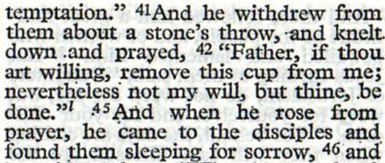

In the main text, which is all that would be read in a typical public reading, the episode of the attack on Him has been deleted! There is a footnote giving the missing verses, but they are not credited with authenticity.

Let's see how it's presented in NA²⁶, (Nestle-Aland, 26th edition):
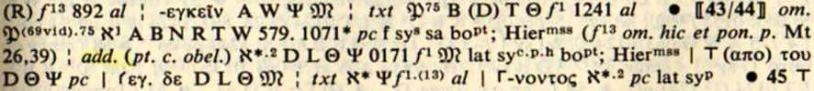
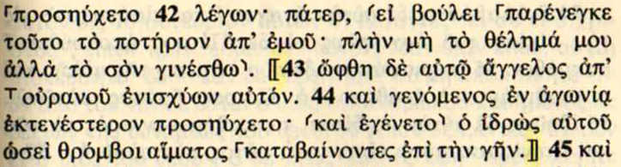

The Introduction says,
Readings enclosed in double brackets, 〚 〛, however, are known not to be a part of the original text.

So NA²⁶ claims the omission is a fact. The apparatus shows that Vaticanus omits the text, but Sinaiticus (first hand) contains it. The symbol 𝔐 stands for the Majority Text (over a thousand manuscripts here), and, in NA²⁶, any of the "constant witnesses" not listed in opposing readings. That is how NA²⁶ obscures the evidence of the important uncials K Q ΓΔ.

Let's look at the evidence, from Reuben Swanson's presentation. Although the bulk of manuscripts are compressed into the symbol 𝔐, the Majority Text, we get a clearer picture of the evidence. N.B. Swanson is not a supporter of the Majority Text.
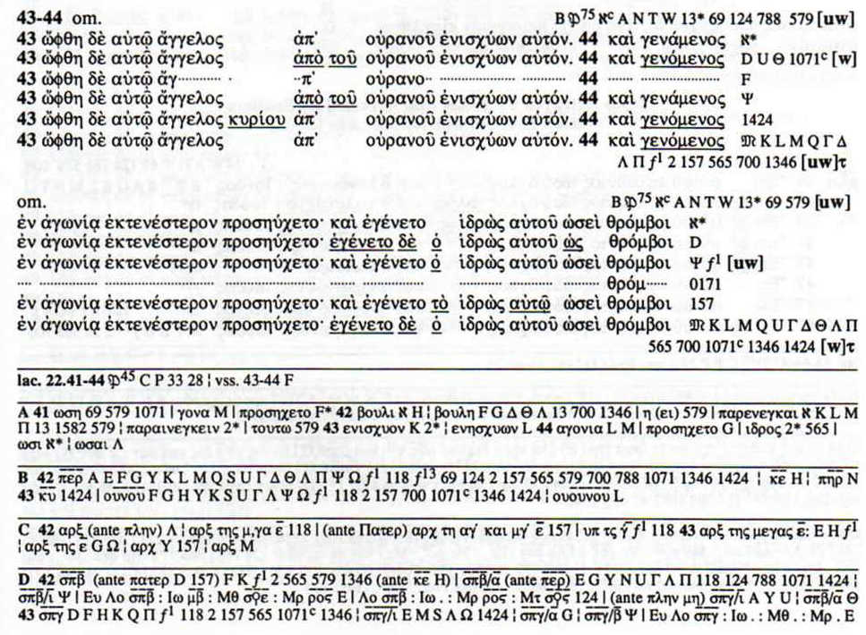

We see that the physical attack on the Lord has very good textual support, especially when we remember that the symbol 𝔐 stands for over a thousand manuscripts.

Rest assured that the Majority Text is the true text. Dr Leslie McFall, and on a smaller scale, I, have shown in separate studies that when Sinaiticus and Vaticanus differ, one of the readings is almost always the Majority Text. And it is the Majority Text that has "God was manifested in the flesh" in 1 Tim 3:16, Sinaiticus being a rogue with just 7 out of about 570 minuscules as support.

Not only is the account of the physical attack on the Lord itself under attack in Luke's gospel. Hebrews 5:7 is under attack by textual critics, even though there is not a single manuscript to support the change which is conjectured. Below is NA²⁶ on the matter.
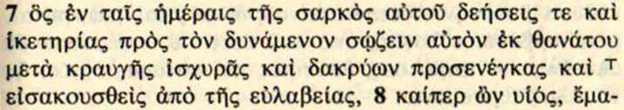

We see that Adolf von Harnack, who was a German Lutheran theologian and prominent church historian, has made a conjectural change to the text, which obviously meets with credibility in the eyes of NA²⁶ (otherwise the entry would not be there): he conjectures that the text should add the word “not” and read:
And in the days of his flesh he made supplications and entreaties with loud cries and tears to him who was able to save him from death, and he was not heard ...

In other words, we are back to Jesus in contention with God, but this time not via interpretation, but via a textual argument (even without textual evidence!), so we are back to this scenario:
Jesus: Please God, let me avoid the crucifixion.
God: No, I will not hear you. You get on with your job.

Harnack said [from Wikipedia]:
That the earth in its course stood still; that a she-ass spoke; that a storm was quieted by a word, we do not believe, and we shall never again believe; but that the lame walked, the blind saw, and the deaf heard will not be so summarily dismissed as an illusion.

To Harnack, God who created the world is incapable of making the earth stand still, making an ass speak, or quieting a storm. Presumably he has no place for the resurrection.

Let us rejoice that our Lord had a very different spirit, and remember what He did for us.

Lk 9:51 | And it came to pass, when the time was come that He should be received up, He stedfastly set His face to go to Jerusalem, | Now it came to pass, towards the completion of the days to him being taken up, that he resolutely disposed himself to go to Jerusalem.

Christ accomplished His mission, was crucified, and was resurrected after three days and three nights, and became the assurance of resurrection for all those who believe.

Jn 11:25 | Jesus said unto her, I am the resurrection, and the life: he that believeth in Me, though he were dead, yet shall he live: | Jesus said to her, “I am the resurrection and the life. He who believes in me, even if he dies, he will live.

Let's conclude, not with just the resurrection, but with the out-resurrection.

Phil 3:7 | But what things were gain to me, those I counted loss for Christ. | but whatever things were gains to me, those I consider a loss because of Christ –
Phil 3:8 | Yea doubtless, and I count all things but loss for the excellency of the knowledge of Christ Jesus my Lord: for Whom I have suffered the loss of all things, and do count them but dung, that I may win Christ, | and indeed I even count everything to be a loss by reason of the pre-eminence of knowledge of Christ Jesus my Lord, for whom I have suffered the loss of everything, and I count them dung in order that I may gain Christ,
Phil 3:9 | And be found in Him, not having mine own righteousness, which is of the law, but that which is through the faith of Christ, the righteousness which is of God by faith: | and that I may be found in him, not having my own righteousness which is from the law, but that which is through faith in Christ, the righteousness from God based on faith,
Phil 3:10 | That I may know Him, and the power of His resurrection, and the fellowship of His sufferings, being made conformable unto His death; | so as to know him and the power of his resurrection and the fellowship of his sufferings, being conformed to his death,
Phil 3:11 | If by any means I might attain unto the resurrection of the dead. | if somehow I can attain to the out-resurrection of the dead.

References

NA²⁶ (Nestle-Aland 26th edition text)

Nestle-Aland, Novum Testamentum Graece, 26 Auflage,

Deutsche Bibelgesellschaft , P.O.Box 810340, 7000 Stuttgart 80, Germany.

RSV The Revised Standard Version, Second Edition, 1971. Published by Collins.

Swanson Reuben Swanson (Editor), New Testament Greek Manuscripts, Luke. Sheffield Academic Press / William Carey International University Press. ISBN 1-85075-774-7.

Brief quotations from these references have been embodied in this critical article.

With capitalized divine pronouns.
See p.50 of the Introduction.

